|  |
| --- |
| Gameli |
| Archer |
| COMP305 Assignment 01  **F:\Li_(李).svg.png** |
| Version #1.0  All work Copyright © 2015 by GameLI Games.  All rights reserved. |
| **Jeff Li** |
|  |

|  |
| --- |
| October 5th 2015 |

**Table of Contents**

Version History – 3

Detailed Game Description - 5

Controls – 5

Interface Sketch – 5

Screen Descriptions – 5

Characters – 6

Enemies – 6

Scoring – 7

Sound Index – 7

Art / Multimedia Index - 7

**Version History**

Versions according to GitHub commits in repository

<https://github.com/TheOneRed/Archer>

**Version 1**

* Character implemented in game with functionality such has movement, speed and shooting
* Enemy implemented in game with movement on the x-axis and random spawning on the y-axis
* Simple Enemy AI implemented (just up and down)
* Background picture scrolling to the left and resets to make it look like an endless background on camera
* Camera does not move
* **Added background music** and an audio clip when the player shoots an arrow
* Resolution made to fit 640x480
* Added score system
  + Player set with 5 lives and 0 score
  + Arrow colliding with ninja = 200 points
  + Enemy colliding with player = lose 1 life
* Player does not die even if life value equals or goes below zero
* Enemies do keep appearing even after death, therefore leaving the game at stalemate

**Version 2**

* Implemented a pick up for player to gain more points
* Jewel (pick up) is set to spawn at random range in y-axis and begins to appear 5 seconds at the beginning of the game and moves left. One jewel will spawn every 15 seconds after the jewel has been collected or has exited the camera view
* Enemy can collide with jewel
* When arrow collides with jewel, arrow is destroyed and jewel keeps moving left
* **CHANGES FROM VERSION 1 ARE STATED BELOW:**
* Revised score system
  + Arrow colliding with ninja = 100 points
* When arrow collides with enemy, the enemy game object is not destroyed but is no reset to spawn position to re-enter the game

**Version History (Cont’d)**

**Version 3**

* Added a boundary outside at the right side of the camera to destroy any arrows that do not collide with enemies
* **CHANGES FROM VERSION 2 ARE STATED BELOW:**
* Made the player game object disappear when life value hits zero
* Enemy now does not collide with jewel, settings has been changed in Project Settings – 2DPhysics – Layer Collision Matrix
* Revised score system
  + Arrow colliding with ninja = 50 points
  + Player colliding with jewel = 300 points

**Version 4**

* Created a “Game Over” UI overlay when player dies. Shows “Game Over” text and below it how many points the player has gained
* Created a restart function that only activates when player dies and the button “R” is pressed. Text is shown at “Game Over” Screen
* Added audio sources when an enemy is hit, a jewel is collected and when the “Game Over” UI is displayed
* **Implemented another pick up for player to gain life (no audio source). Heart can be destroyed by shooting it, making the player lose points**
* **CHANGES FROM VERSION 3 ARE STATED BELOW:**
* Player is now able to destroy the jewel by shooting it and loses points rather than gaining points
* Revised / Final score system
  + Player set with 5 lives and 0 score
  + Player colliding with ninja = lose 1 life
  + Player colliding with jewel = 200 points
  + Player colliding with heart = gain 1 life
  + Arrow colliding with ninja = 50 points
  + Arrow colliding with jewel = -100 points
  + Arrow colliding with heart = - 500 points

[This is the body of your video game design document. You should add and delete sections as they pertain to your game’s design.]

1. **Detailed Game Description**

A 2d shooter game. The goal of the game is to get as many points as possible before dying. The player can move left and right in an area and can fire an arrow towards the left side to kill enemies which spawn from the right side. Killing enemies rewards the player for points. There are special pickups in the game that can help the player gain more points and lives, but if accidently destroyed, will make the player lose points. When the player dies, it shows the final score and the user can press “R” to play again.

1. **Controls**

* *“WASD” or arrow keys are used for movement*
* *Left mouse button makes the player shoot an arrow*

1. **Interface Sketch**

*(What does the game interface look like? Provide a screen shot or sketch)*

1. **Screen Description**

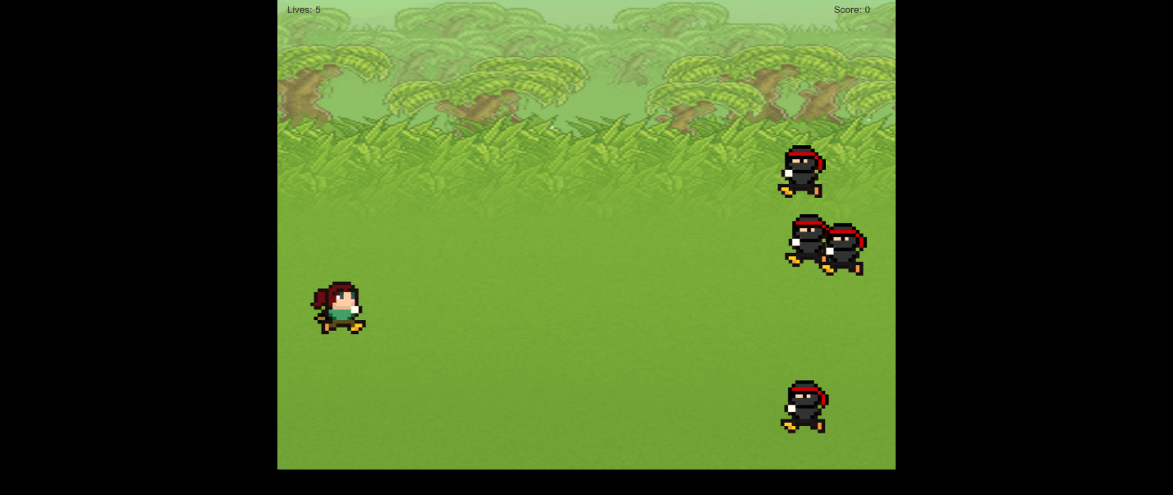Starting the game (resolution is 1280x1024 so that you can see the game more clearly)

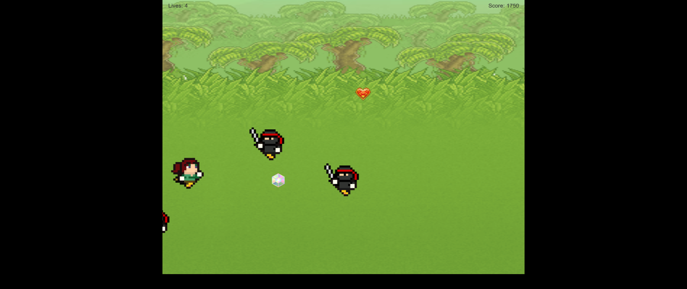Game play showing heart/jewel/enemy/score

Game Over screen showing final score and restart function

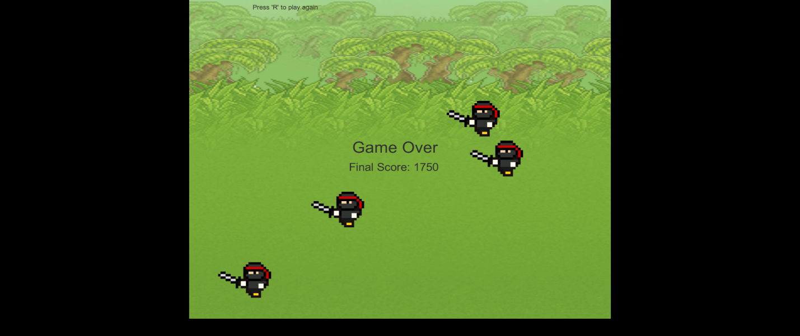

1. **Characters**

* Female 8-bit character, brown hair, has a bow on her back

1. **Enemies**

* 8-bit ninja enemies that move left on the x-axis and spawning at random points on the y-axis. Also moves at a random speed and moves up and down.

1. **Scoring**

* When arrow collides with enemy ninja, gain 50 points
* When arrow collides with jewel, lose 100 points
* When arrow collides with heart, lose 500 points
* When player collides with jewel, gain 200 points
* When player collides with enemy ninja, lose 1 life
* When player collides with heart, gain 1 life

1. **Sound Index**

* Arrow Shot <http://soundbible.com/1780-Bow-Fire-Arrow.html>
* Enemy dying <http://opengameart.org/content/grunts-male-death-and-pain>
* Back ground Music <http://opengameart.org/content/title-x>
* Jewel pick up – Coin 3 – Arcade SFX Free / Unity Asset Store
* Jewel destroy – empty - Arcade SFX Free / Unity Asset Store
* Game Over – Dive 3 - Arcade SFX Free / Unity Asset Store

1. **Art / Multimedia Index**

Main Character <http://opengameart.org/content/ranger-animated>

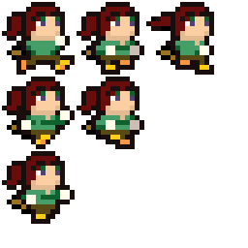

**Art / Multimedia Index (Cont’d)**

Enemy http://opengameart.org/content/ninja-animated

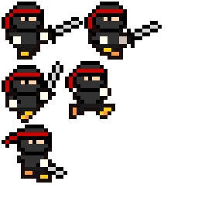

Jewel <http://omniferious.deviantart.com/art/Auroura-Jewel-s-Cutie-Mark-267850852>



**Art / Multimedia Index (Cont’d)**

Arrow <http://forums.terraria.org/index.php?threads/terraria-mod-idea-starter-classes.31576/>



Heart <http://opengameart.org/content/heart-3>



Terrain (I forgot to bookmark the site and I can’t seem to find it anymore)

